HTML Versions

📘 Definition
# Source: AI Source: Provided by: [Data Path: Persons Table -> ID Column: 1, Name_En Column: Motasem Essam] -> From: [ChatGPT] on [5/6/2026]
HTML versions are different releases of the HTML language over time.
Each version adds new features, improves structure, and removes outdated elements.

🌍 The Beginning of the Web (1989)
📖 Description
Tim Berners-Lee proposed the idea of the:
- World Wide Web (WWW)
- Hypertext system for sharing documents
👉 This became the foundation of HTML.

🕰️ Main HTML Versions
# Source: AI Source: Provided by: [Data Path: Persons Table -> ID Column: 1, Name_En Column: Motasem Essam] -> From: [ChatGPT] on [5/6/2026]
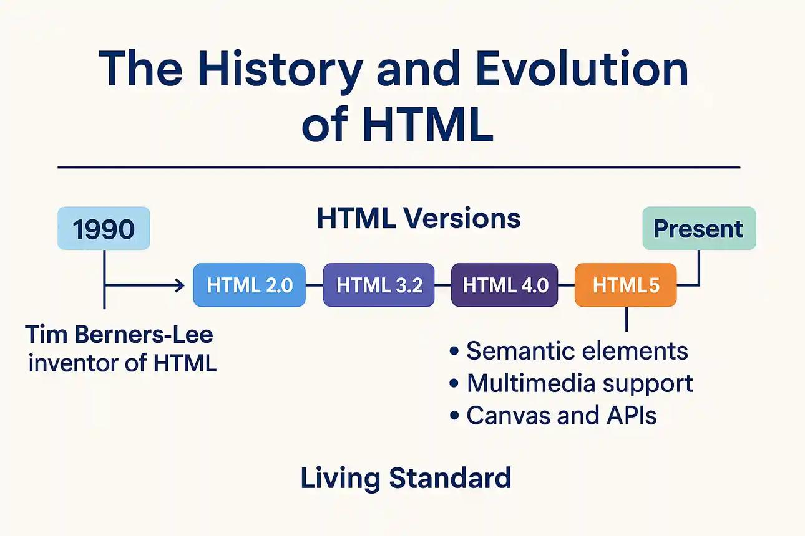
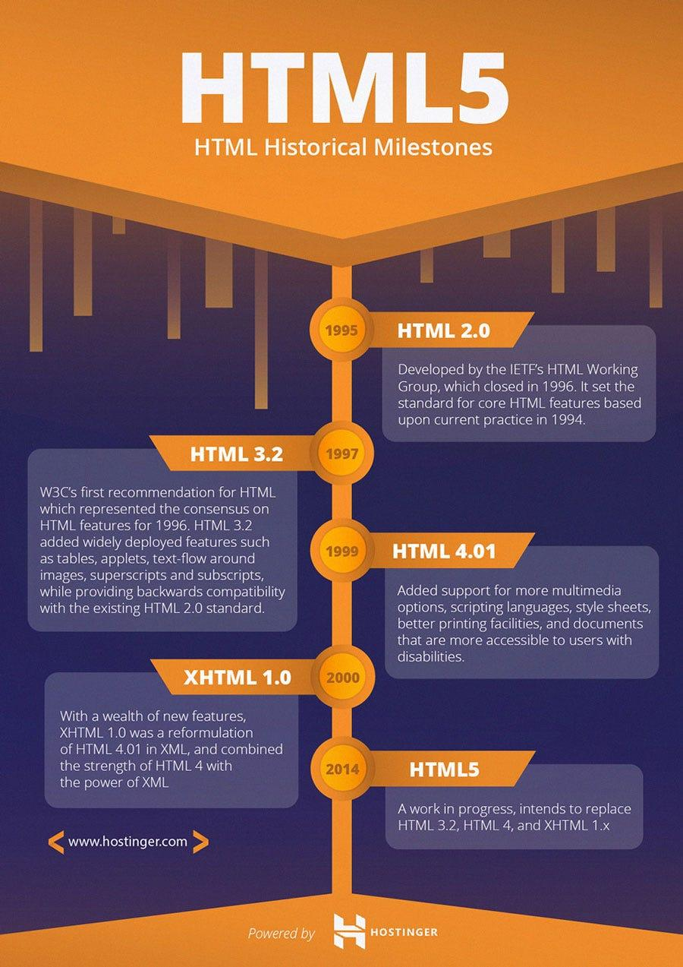
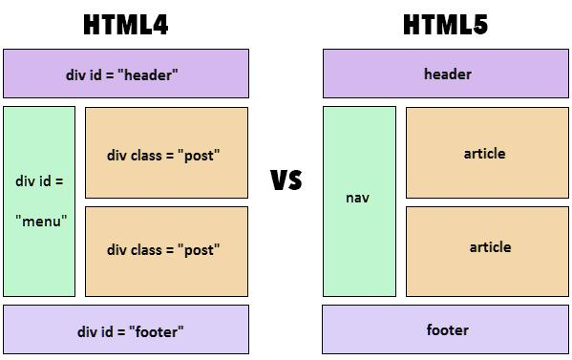

📜 1. HTML 1.0 (1991)
# Source: AI Source: Provided by: [Data Path: Persons Table -> ID Column: 1, Name_En Column: Motasem Essam] -> From: [ChatGPT] on [5/6/2026]
📖 Description
The first version of HTML was created.
Features:
- Basic text pages
- Links (<a>)
- Simple headings and paragraphs
❌ No CSS
❌ No multimedia

📜 2. HTML 2.0 (1995)
# Source: AI Source: Provided by: [Data Path: Persons Table -> ID Column: 1, Name_En Column: Motasem Essam] -> From: [ChatGPT] on [5/6/2026]
📖 Description
First official HTML standard.
Added:
- Forms
- More structured elements
👉 Helped websites become interactive

📜 3. HTML 3.2 (1997)
# Source: AI Source: Provided by: [Data Path: Persons Table -> ID Column: 1, Name_En Column: Motasem Essam] -> From: [ChatGPT] on [5/6/2026]
📖 Description
Added more visual and layout features.
Added:
- Tables
- Scripts
- Applets
- Better formatting

📜 4. HTML 4.01 (1999)
# Source: AI Source: Provided by: [Data Path: Persons Table -> ID Column: 1, Name_En Column: Motasem Essam] -> From: [ChatGPT] on [5/6/2026]
📖 Description
Focused on:
- cleaner structure
- accessibility
- separating design using CSS
Important Change:
👉 CSS became the preferred styling method

🚀 5. HTML5 (2014 → Now)
# Source: AI Source: Provided by: [Data Path: Persons Table -> ID Column: 1, Name_En Column: Motasem Essam] -> From: [ChatGPT] on [5/6/2026]
📖 Description
Modern version of HTML used today.
Added:
  - 🎬 Video & audio (no plugins needed)
  - 🎨 Canvas graphics
  - 📱 Mobile-friendly design
  - ⚡ JavaScript APIs
  - Semantic elements (<header>, <section>, etc.)
👉 Replaced Flash and old technologies

⚖️ HTML Evolution Summary
# Source: AI Source: Provided by: [Data Path: Persons Table -> ID Column: 1, Name_En Column: Motasem Essam] -> From: [ChatGPT] on [5/6/2026]
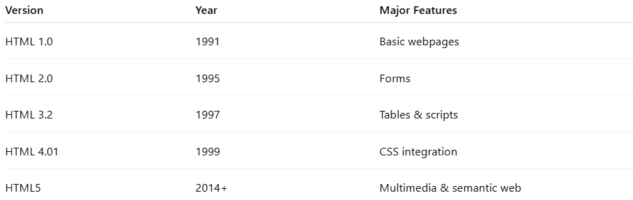
Version | Year | Major Features
HTML 1.0 | 1991 | Basic webpages
HTML 2.0 | 1995 | Forms
HTML 3.2 | 1997 | Tables & scripts
HTML 4.01 | 1999 | CSS integration
HTML5 | 2014+ | Multimedia & semantic web

🌐 Organizations Behind HTML
# Source: AI Source: Provided by: [Data Path: Persons Table -> ID Column: 1, Name_En Column: Motasem Essam] -> From: [ChatGPT] on [5/6/2026]
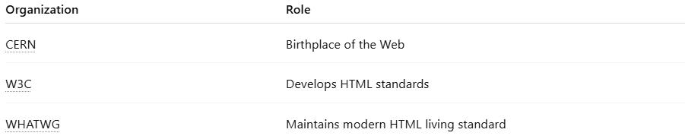
Organization | Role
CERN | Birthplace of the Web
W3C | Develops HTML standards
WHATWG | Maintains modern HTML living standard

🚀 In short:
# Source: AI Source: Provided by: [Data Path: Persons Table -> ID Column: 1, Name_En Column: Motasem Essam] -> From: [ChatGPT] on [5/6/2026]
HTML versions are the stages of HTML development, from simple text pages (HTML 1.0) to modern interactive websites (HTML5).

